Circuit Analysis
Lab 11
Assignment

Submitted by:
Wardah Shahid
2025-CE-81

University of Engineering
and Technology

Circuit(To find load current):
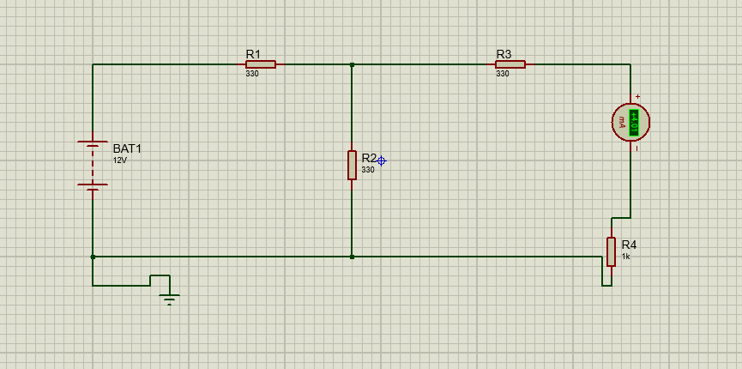
Explanation:
The circuit is constructed by connecting a 12V DC voltage source to a T-shaped resistor network, where a 330Ω horizontal resistor connects from the positive terminal to a central junction, a second 330Ω resistor drops vertically to the ground line, and a third 330Ω resistor connects from the junction in series with a DC ammeter (set to mA range) and a 1kΩ vertical load resistor, with the entire loop closed back to the common ground terminal.

Circuit(To find In ):
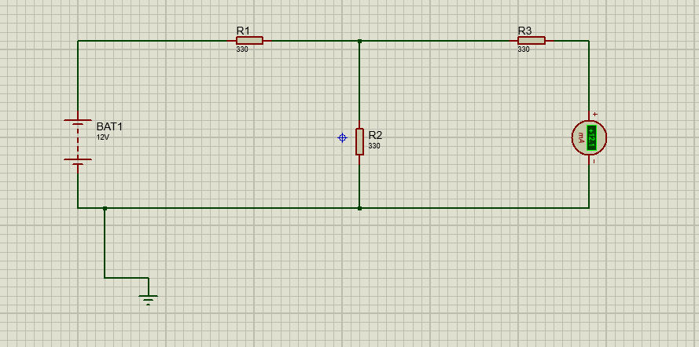

Explanation:
It is created by removing the 1kΩ load resistor from the first setup and connecting the DC ammeter's negative terminal directly to the bottom ground wire, creating a direct short across the load terminals that bypasses the vertical 330Ω resistor so the ammeter can read the maximum Norton current.

Circuit (Norton’s equivalent circuit):
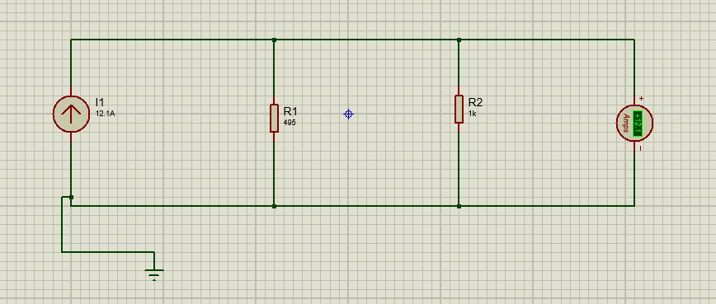

Explanation:
The final Norton equivalent circuit is built by placing a constant DC current source (set to 36.36 mA with the arrow pointing upward) in parallel with a 495Ω resistor representing the Norton internal resistance, and then connecting the original 1kΩ load resistor in series with a mA ammeter across this parallel combination to ground, allowing the current to divide and verify the theorem.

Table:
